Find the area of each quadrilateral
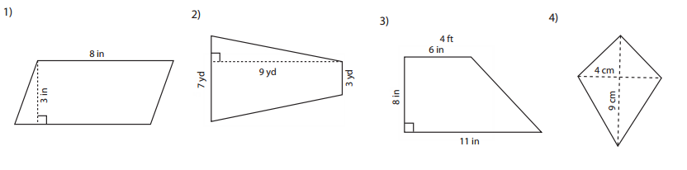

Find the perimeter of each quadrilateral
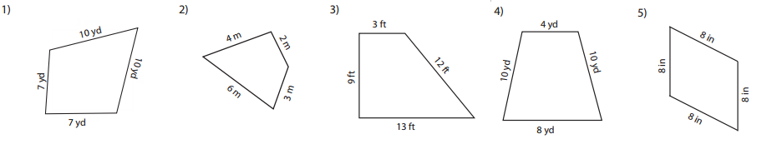

Find the area of each irregular shape
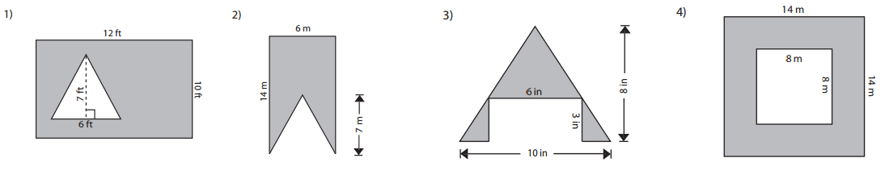

Identify the smallest and largest angle for each triangle
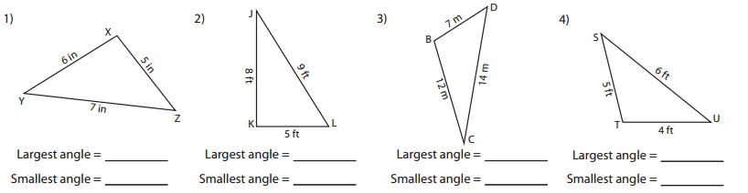

Identify the shortest and longest side for each triangle

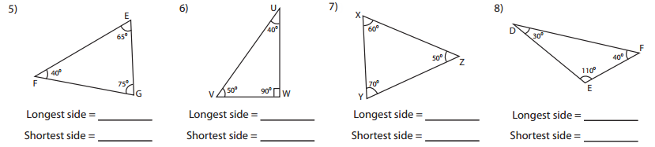

Applying triangle inequality theorem, identify whether the triangle is possible or not possible with the given side measures.
